### Adding a User Group

To add a new user group, select the appropriate parent group. For most new user groups, this will be the *Master Users Group*. After selecting the appropriate parent user group, click the **Add a Child User Group** button.

Note: the message “You cannot modify Master Users Group” means you are not able to edit or delete the top-level group, but does not prevent you from adding a child user group.

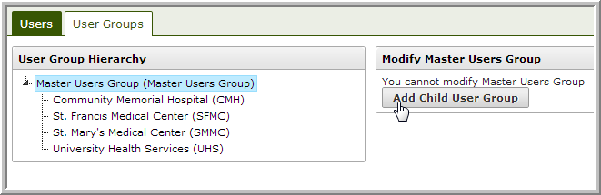

After clicking Add Child User Group, a new text box will appear with the word **Code** highlighted. Create an easily identifiable code or abbreviation for the User Group and hit enter. Departments or additional locations of an existing group should be added beneath this child group.

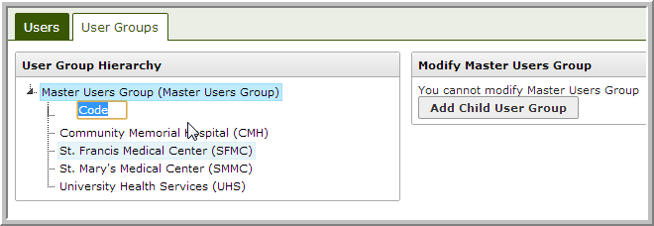

The new user group will appear at the top of the list in parentheses. To complete the setup, click on the name.

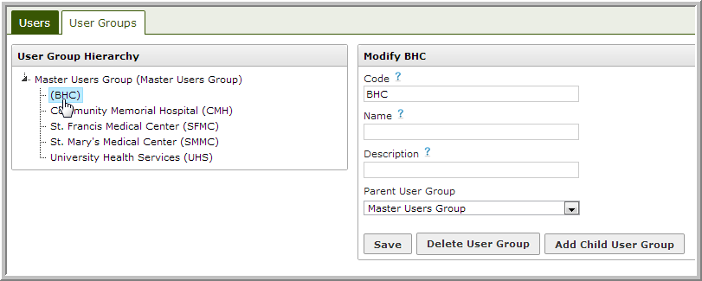

Tooltips will appear when hovering your cursor over the question mark by each field.

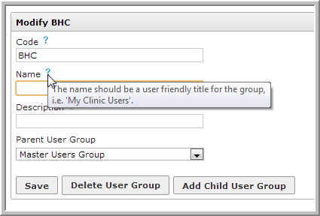

Edit all desired fields and click **Save**.